**BRAND RATIONALE**

**Client / Brand:** Regional Cancer Care Associates – Central Jersey Division

**Account/Project Manager:** Rachel Schmidt

**Date:** February 3, 2016

**What are we trying to accomplish?**

Our key challenge.

Build a compelling, recognizable brand and coherent messaging to:

* increase local awareness of RCCA-CJD
* increase physician referrals
* grow percentage of cancer cases
* protect existing market share and compete to keep patients from leaving Central Jersey for cancer care
* Achieve 10% growth in new-patient volume *and* in revenues

**What are we promoting?**

Top-quality, comprehensive and compassionate cancer care without needing to leave Central Jersey.

**What sort of people are we talking to?**

Psychographic description of the target audience.

All cancer patients, their loved ones, and all medical professionals involved with cancer care.

**What key emotional insight(s) have we identified?**

Driving emotional insights in the marketplace.

The perception that receiving quality cancer care requires leaving Central Jersey; cost-conscious; desire excellent care; need compassion, understanding and support.

**What is the brand’s position in its marketplace?**

What “place’ in the marketplace should this brand be claiming? Must be true, memorable, differentiating and compelling.

Expert, experienced and reputable doctors dedicated to defeating cancer in our communities.

**What are we promising to our audience?**

Translation of the positioning into language that’s meaningful to the target audience?

Expert cancer care, reliable experience, genuine compassion and real hope.

**Why should they believe our promise?**

Proof points.

* Treat all types of cancer
* Top-quality cancer care
* Excellent reputation backed by true expertise
* 18 dedicated, well-trained, experienced cancer specialists
* Leaders – state-of-the-art care; instructors of residents/fellows
* Fully capable; comprehensive
* Latest medical/oncologic methods and equipment
* Collaborative; coordination of all care
* Accessible, flexible and responsive
* Whole-person approach
* Close to home; needn’t travel to major centers
* Very caring, compassionate and dedicated people
* High level of professionalism
* In-house pharmacy services and expertise
* Participation in clinical trials
* Deep network of referral and support resources
* Convenient – locations, languages, appointments in 48 hours or less

**What is our brand essence?**

That one-word or one-phrase feeling or attitude to incite creative.

Dedicated

**What is the brand’s personality? What does it *feel* like?**

Dominant, driving personality traits (tonal direction). Is this the “fatherly” doctor? The “gentle” doctor? The “leading-edge” practice? The “compassionate” team?

Reliable, trustworthy, capable, confident, dedicated, caring

**Positioning-Based Tagline**

The tagline — based on the above marketing rationale and intended to appear wherever your practice name appears — is the fundamental expression of your brand.

**Regional Cancer Care Associates**

**Central Jersey Division**

*Leaders in advanced, compassionate cancer care close to home.*

*Expert specialists. State-of-the-art care. Close to home.*

*Advanced, experienced, dedicated cancer care close to home.*

*Advanced, compassionate cancer care close to home.*

**Marketing Bullets**

These bullet lists — and their positioning-based subheads — are additional expressions of your brand that will appear in various marketing projects, including the back of the Presentation Folder, the Brochure and certain external tactics, such as Print Ads.

***Comprehensive, leading-edge cancer care & hematology…***

• Cancer diagnosis, staging, treatment & care coordination

• Genetic counseling

• Chemotherapy, including targeted therapies

• Immunotherapy

• Biological & hormone therapy (?)

• Coordination of radiation therapy, surgical treatment & supportive care

• Pain management & palliative care

• Research & clinical trials

• On-site oncology pharmacy services & expertise

• Diagnosis, treatment & management of blood-related disorders

• Patient education, counseling & support

• Hospice care

***Compassionate, results-focused care & support for…***

• Breast cancer

• Lung cancer

• Colon cancer

• Prostate cancer

• Myeloma

• Lymphoma

• Leukemia

• Melanoma

• Pancreatic cancer

• Esophageal cancer

• Stomach cancer

• Ovarian cancer

• Head & neck cancer

• Liver cancer

• Brain tumors

• Blood disorders

***The caring, convenience & accessibility you deserve…***

• Compassionate, dedicated doctors, nurse-practitioners, nurses & support staff

• Individualized, patient-first care

• 5 convenient locations in Central NJ

• Newly diagnosed patients seen within 48 hours

• Radiology precertification

• Insurance accepted & filed

• After-hours physician available by phone

• Anytime-anywhere secure patient access to records

• On-staff financial advocates

• Languages spoken: English, Spanish, Portuguese, Mandarin Chinese, Fukienese Chinese, Italian, Tagalog, Urdu, Hindi, Punjabi, Gujarati

**Logo**

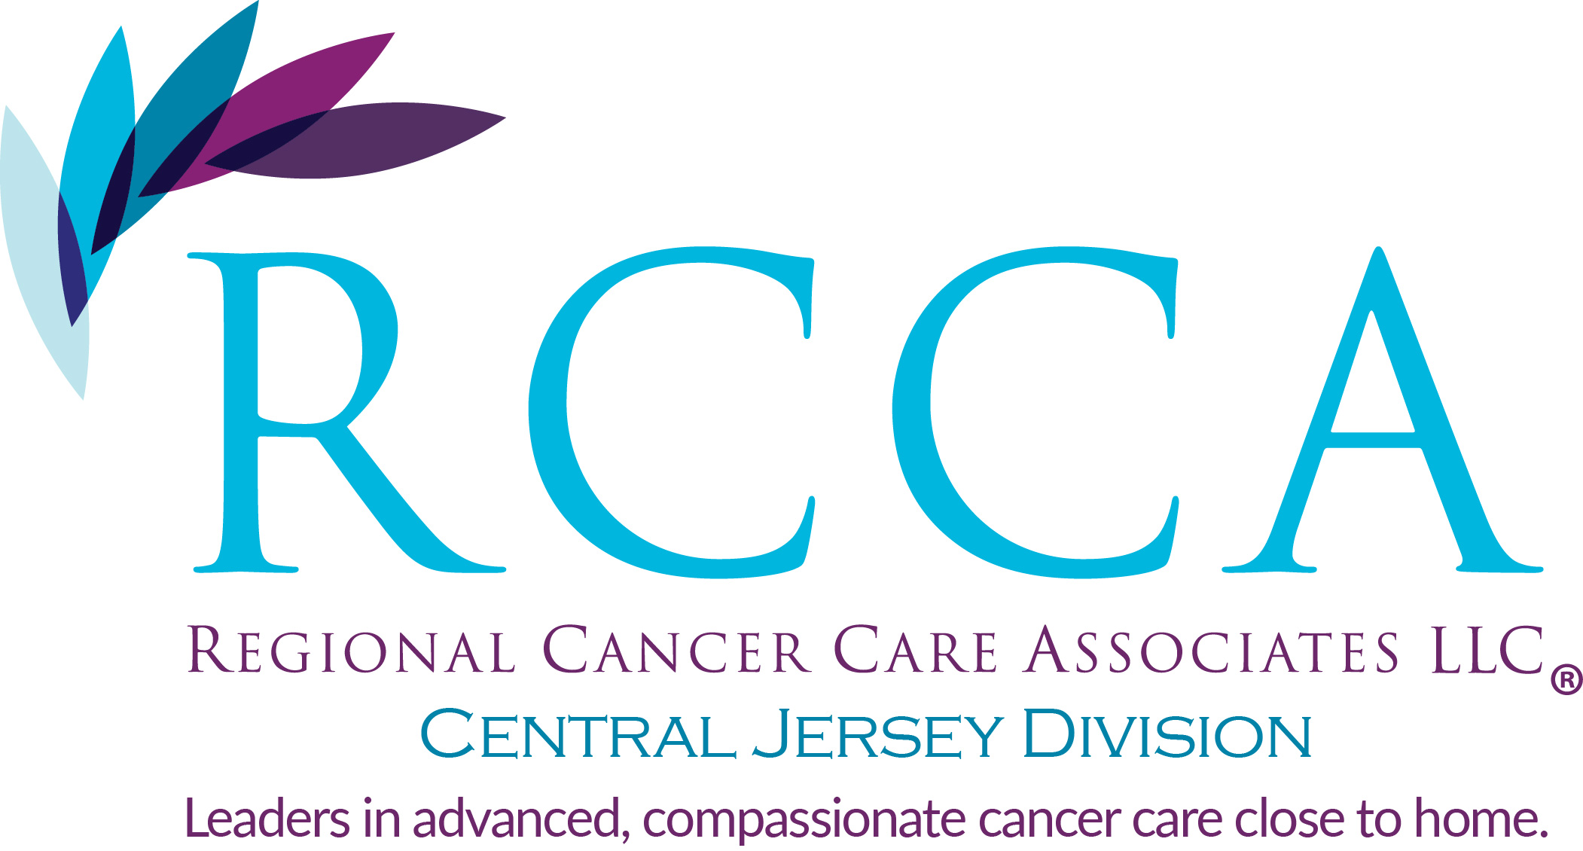

**Color Palette**



**Brochure Cover**

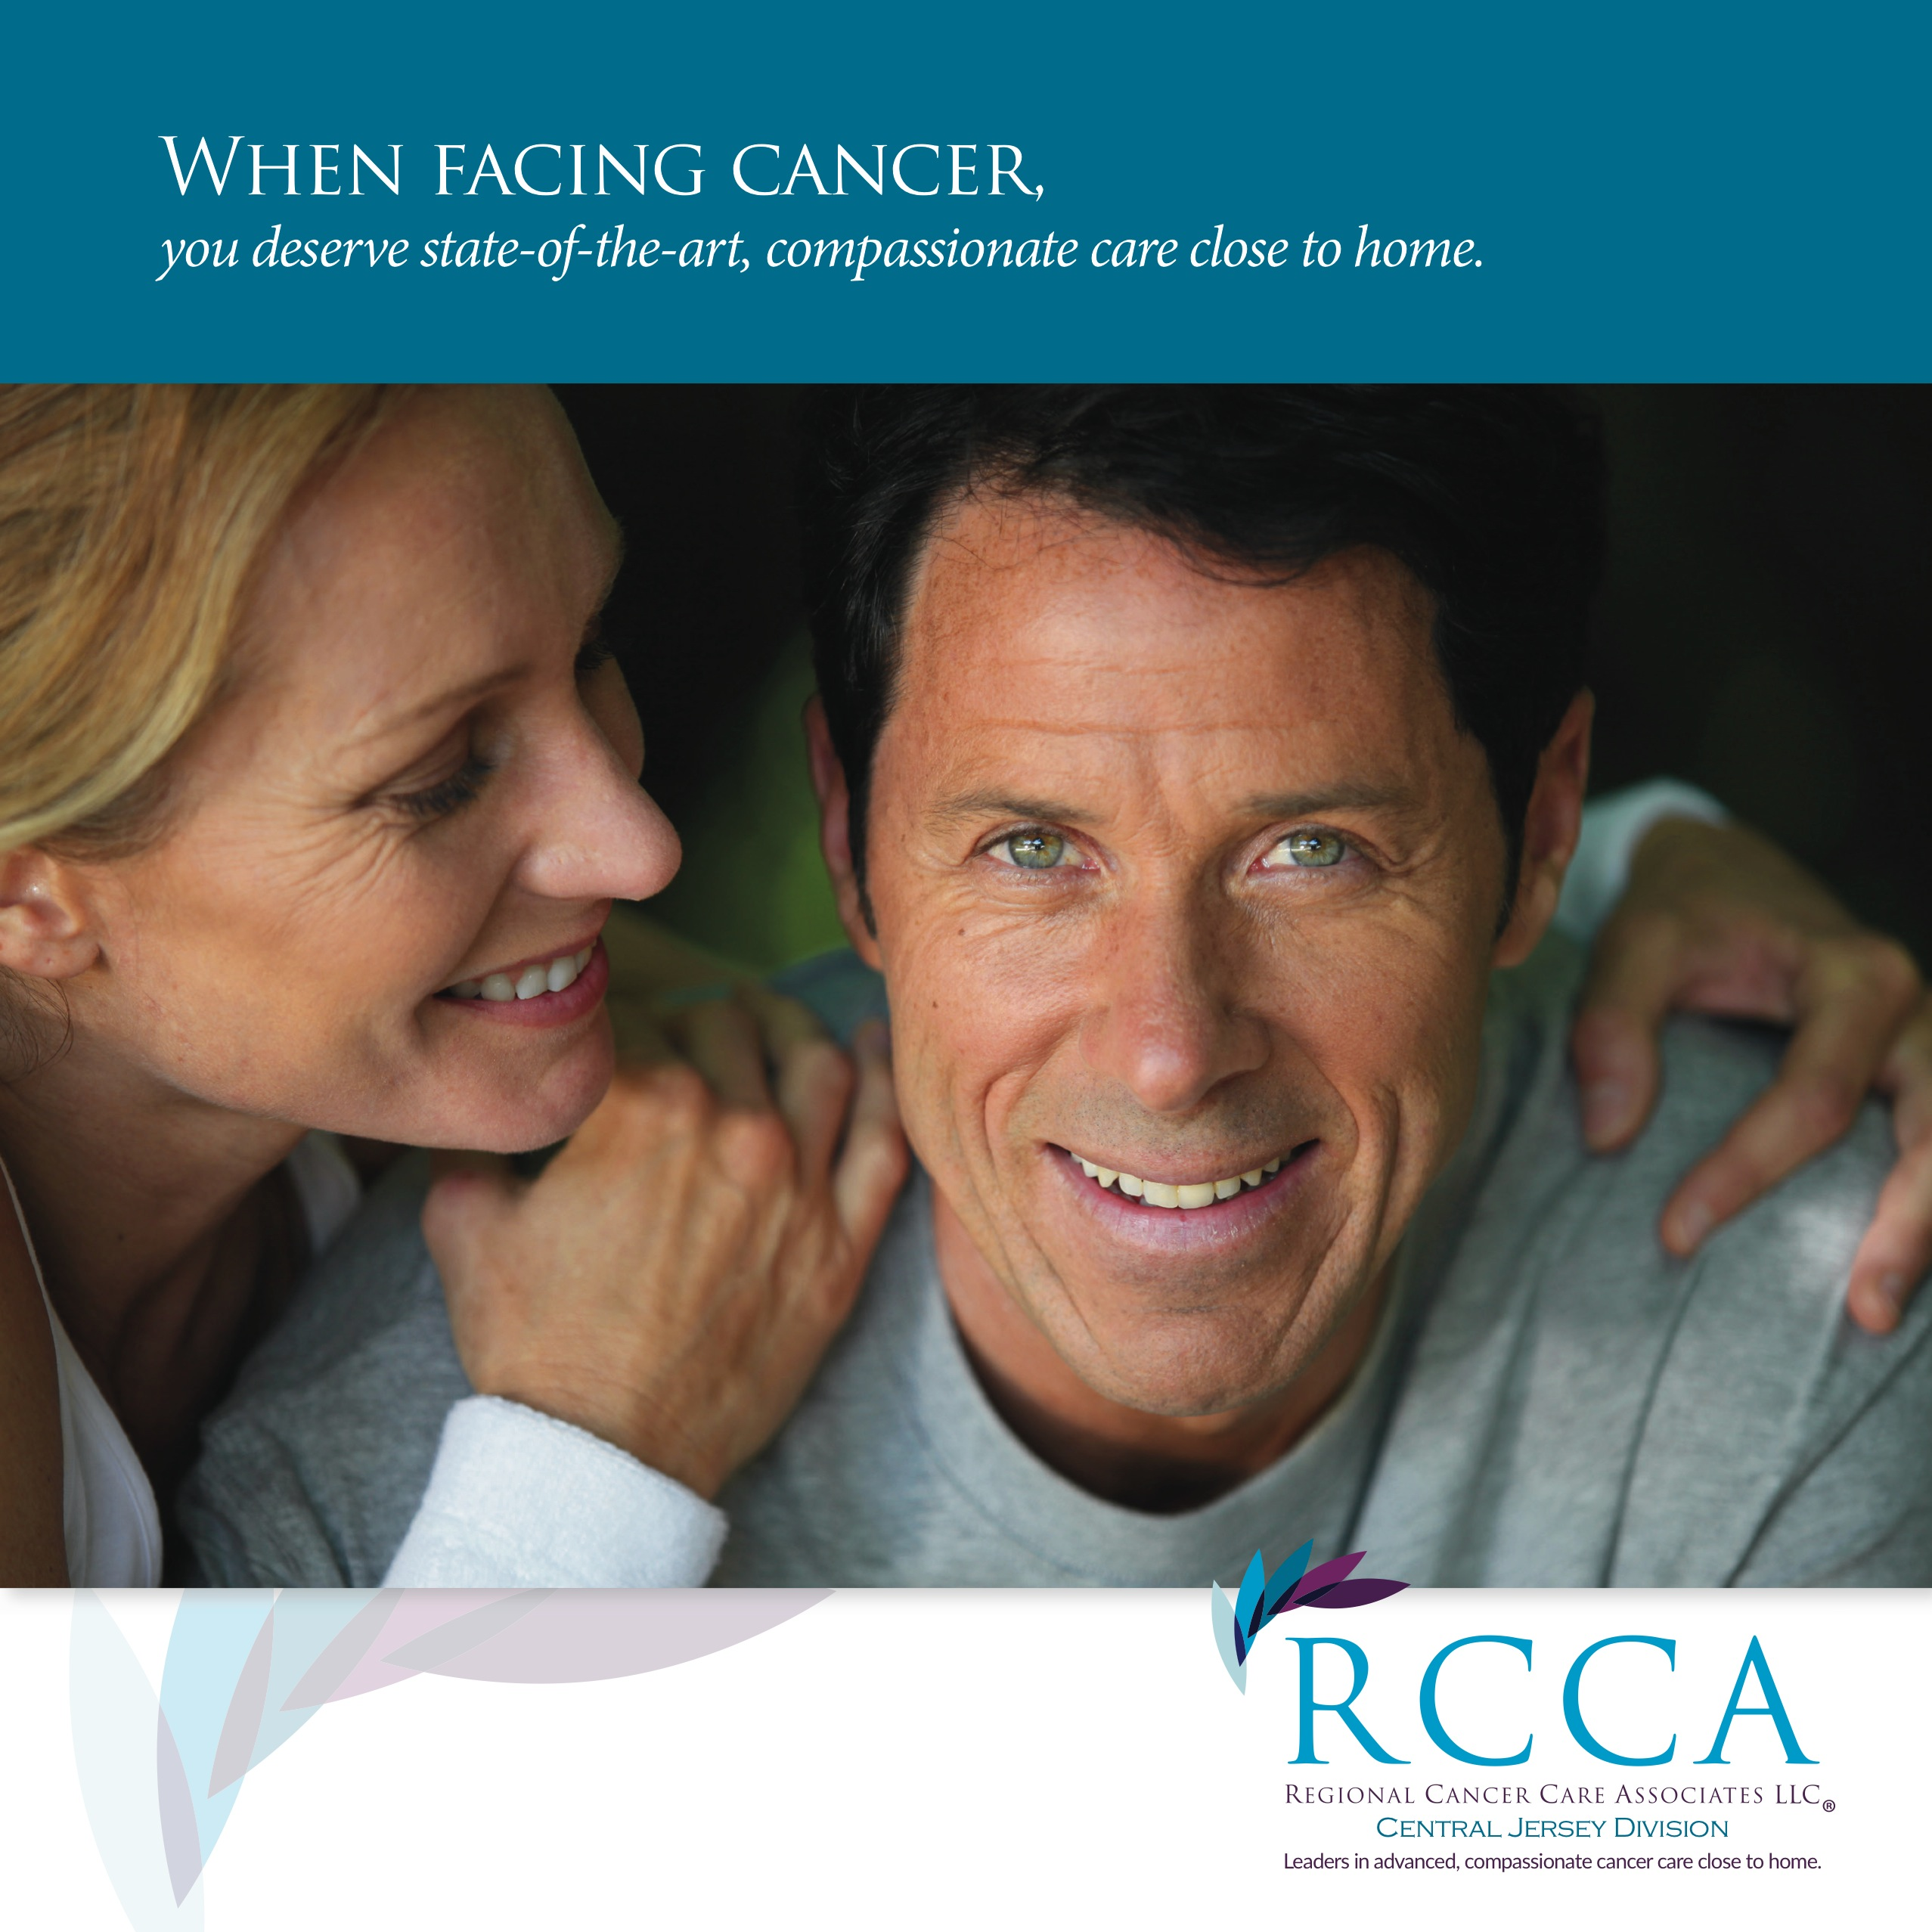

Headline:

***State-of-the-art cancer treatment and dedicated, compassionate care in Central Jersey.***

Intro Body Copy:

A cancer diagnosis changes everything.

At the Central Jersey Division of Regional Cancer Care Associates, we understand this. That’s why our highly trained, experienced and reputable cancer doctors are — along with our nurse-practitioners, nurses, pharmacist and other team members — are completely dedicated to your best interests and optimal health. It’s also the reason we provide the highest standard of cancer and hematology care, and why we bend over backwards to deliver the support, education and individualized attention you need to win your fight.

*- end -*