Thank You and Congratulations, Saint Peter’s Healthcare System!

We Appreciate Your Outstanding Contributions and Commitment to The Communities and People We Serve!



At RCCA Central Jersey Division, we’re grateful and excited to be a part of Saint Peter’s quest to deliver outstanding, appropriate and effective care to the people of our shared New Jersey communities. We’re also honored to be able to work with and support — and now congratulate! — this year’s award honorees!

|  |  |
| --- | --- |
| **Bishop’s Award**  **Honoree:** University Radiology | **Physician Appreciation Award**  **Honoree:** Dr. I Mark Hiatt  **Honoree:** Dr. Susan McManus |

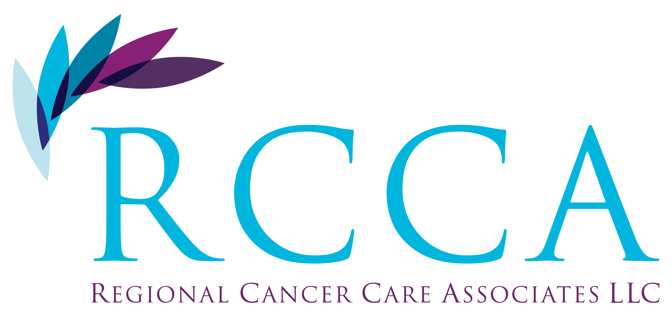

Maqsood Amjad, MD

Brian Canavan, DO

Andrei Dobrescu, MD

Bruno Fang, MD

George Karp, MD

Aysha Khalid, MD

Edward Licitra, MD, PhD

Michael Nissenblatt, MD

Beiqing Pan, MD, PhD

Phillip Reid, MD

Ellen Ronnen, MD

Jonathan Rosenbluth, MD

James Salwitz, MD

Richard Schuman, MD

Kathleen Toomey, MD

Seeta Trivedi, MD

Bruce Wallach, MD

Steven Young, MD

Four Convenient Locations:

East Brunswick 732.390.7750

Edison 908.757.9696

Somerville 732.927.8700

Somerset 732-390-7750

RegonalCancerCare.org