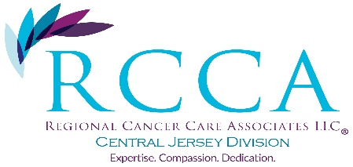

**Patient Transportation Program**

Dear Patient,

During this unprecedented time, the safest place to receive your treatment continues to be right here at Regional Cancer Care Associates, Central Jersey, where our staff is doing everything possible to ensure your safety and comfort. It’s critical that you continue to receive care, and we remain ready to treat you.

**If transportation is a concern, we are offering completely free, professional transportation in licensed and cleaned cars to and from appointments.** The transportation is provided by the Community Oncology Alliance (COA) and Cancer*Care—* two non-profit organizations that we know and trust.

Getting free travel to and from our office with the COA/Cancer*Care* Patient Transportation Program is as easy as 1-2-3:

1. **Call us.** Contact our scheduling team at 732-390-7750 ***at least 24 hours ahead of your appointment*** so we can make your arrangements with Groundlink, the program’s transportation provider.
2. **Provide basic information.** You will provide basic information like your name, pick-up/drop-off locations and times, email address, and mobile phone number.
3. **We handle the rest.** Our staff will contact Groundlink. Groundlink will then confirm WITH YOU your pick-up and drop-off times directly via email; then text or phone you at the time of your appointment.

On the day of pick-up, Groundlink will text or phone you to let you know when to be outside and ready to meet your driver. They will provide the color, make, model, and license plate number of the car they are dispatching and the driver’s name.

When he or she arrives, you can expect to be greeted by a professional wearing medical-grade gloves and a mask who will transport you in a clean, disinfected vehicle directly to your appointment. The driver will ***not*** come to your front door, unless you ask us for assistance between your front door and the vehicle at the time we confirm your appointment.

After the appointment, Groundlink will share information for the vehicle and driver to drop you off at home. The vehicle will arrive clean and disinfected and will be cleaned and disinfected after your trip for the safety of the next passenger.

Again, this program is **completely free**. There is no charge for you, your insurance, or anyone else involved.

Please contact our scheduling staff for more information or to sign up for free transportation. We are pleased to be able to serve patients in need in this way.

Regional Cancer Care Associates, Central Jersey