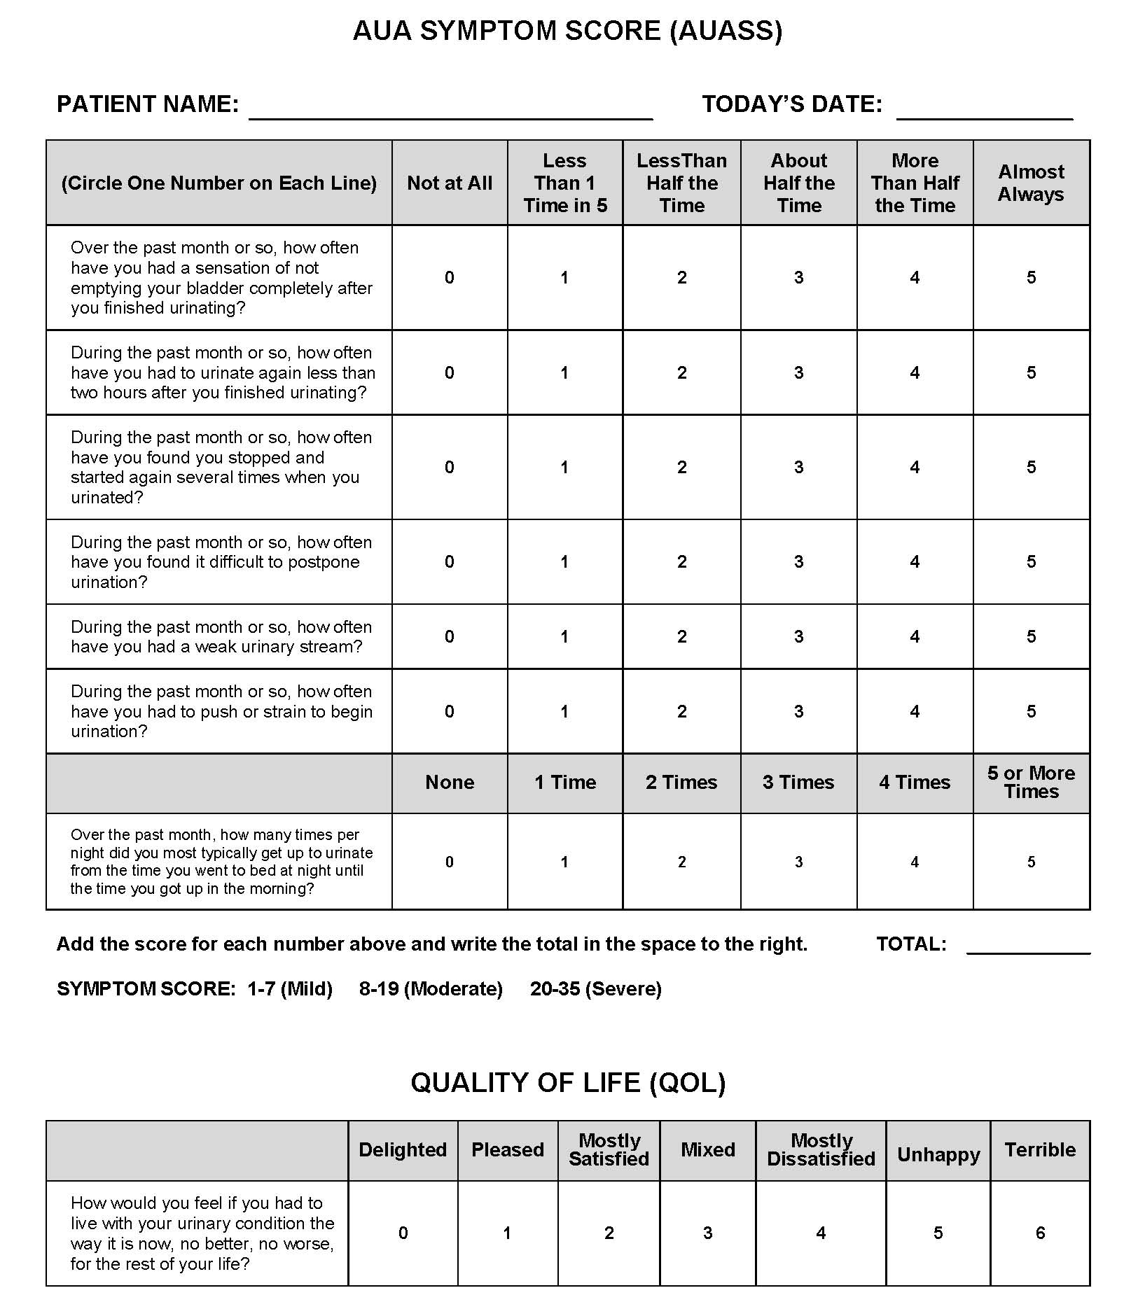

|  |  |
| --- | --- |
|  | **9 Centre Drive, Suite 115**  **Monroe, NJ 08831**  **phone 609-655-5755 ● fax 609-655-5725**  *formerly Princeton Radiation Oncology* |
|  |  |

