**BRAND RATIONALE**

**Client / Brand:** The Block Center for Integrative Cancer Treatment

**Account/Project Manager:** Rachel Schmidt

**Date:** March 1, 2016

**What are we trying to accomplish?**

Our key challenges.

* **Increase patient inquiries and conversions** by communicating a concise, compelling message that differentiates the Block Center from other cancer providers and from “alternative therapies.”
* **Define and cogently present/market “integrative care”** in its truest form.
* **Change the cancer conversation** from standard-line treatment and tumor targeting to one of integrative care and systemic disease process.
* **Establish believability, authority, commitment and success**

**What are we promoting?**

A completely unique, individualized and responsible way of fighting cancer: to win.

**How are we defining “Integrative Care”?**

What is true integrative care as provided by the Block Center?

* **FULL DEFINITION** –Integrative cancer care is that which pulls together the best science-based treatments, therapies and practices and fuses them, weaving them together into treatment plans coordinated to fight cancer on all fronts in a way that will be most appropriate and effective for each individual.
* **SHORT DEFINITION** – “Integrative” cancer care means fighting cancer on all fronts and in a way that will be most effective for each individual by weaving together methods supported by science.

**What sort of people are we talking to?**

Psychographic description of the target audience.

People who are facing cancer (or helping a loved one fight the disease) and contending with the fear, anxiety, helplessness and hopelessness of a new cancer diagnosis, recurrence of cancer, and/or previous treatment.

**What key emotional insight(s) have we identified?**

Driving emotional insights in the marketplace.

* Fear, helplessness, hopelessness, concern, anxiety and stress
* Desire for excellent care
* Need for compassion, understanding and support

**What is the brand’s position in its marketplace?**

What “place’ in the marketplace should this brand be claiming? Must be true, memorable, differentiating and compelling.

The nation’s leader in truly comprehensive care uniquely designed and coordinated to use the best science-based methods to fight cancer on all fronts and in a way that will be most appropriate and effective for each individual.

**What are we promising to our audience?**

Translation of the positioning into language that’s meaningful to the target audience?

Life over cancer.

**Why should they believe our promise?**

Proof points.

There are really too many proof points to cover here, and the need for simplicity (along with limited space) requires that we choose our proof points wisely. But here are the main proof points with regard to the “Truths” we intend to tell:

*• Experienced & at the forefront*

*• Comprehensive*

*• Integrative, including the best of conventional cancer care*

*• Science-based & objective*

*• Motivates & involves patients*

*• Effective / successful*

*• Less toxic*

*• Supportive*

*• Individualized*

*• Compassionate & dedicated*

*• Woven with nutrition, fitness, chronomodulation, biobehavioral care*

*• Willing to implement off-label, overseas and repurposed anti-cancer medications*

**What is our brand essence?**

That one-word feeling or attitude to incite creative.

Amazing (effective) — “The unknown truth about cancer is amazing.”

**What is the brand’s personality? What does it *feel* like?**

Dominant, driving personality traits (tonal direction). Is this the “fatherly” doctor? The “gentle” doctor? The “leading-edge” practice? The “compassionate” team?

Compassionate, confident (experienced), authentic, trustworthy (authoritative), uncomplicated, understanding, dedicated, advanced, leading-edge, sensible, attuned, supportive

**Positioning-Based Tagline**

The tagline — based on the above marketing rationale and intended to appear wherever your practice name appears — is the fundamental expression of your brand.

**The Block Center**

for Integrative Cancer Treatment

*Beating the odds for more than 30 years.*

**Marketing Bullets**

These bullet lists — and their positioning-based subheads — are additional expressions of your brand that will appear in various marketing projects, including the back of the Presentation Folder, the Brochure and certain external tactics, such as Print Ads.

***A unique, individualized & effective approach to life over cancer…***

• Integrative, multifaceted care – fighting cancer on all fronts

• Advanced, extensive lab testing

• Customized, targeted therapies

• Reduced-toxicity treatments

• Innovative methods & equipment

• Whole-person focus & treatment

• Psychosocial counseling & support

• State-of-the-art anticancer nutrition

• Botanical medicine / nutritional pharmacology

• Personalized fitness & mind-body wellness

• Recurrence prevention

• Clinical trials

***Dedicated, caring people partnering with you to…***

• Target & treat disease process, not just tumors

• Boost treatment efficacy

• Reduce toxicity & side effects

• Build physical strength & flexibility

• Restore hope & preserve your dignity

• Decrease chances of cancer recurrence

• Inform, educate & involve patients & family

• Maximize your odds & quality of life

***Comprehensive science-based care for all adult cancers…***

• Breast

• Lung

• Colon

• Stomach

• Ovarian

• Gastrointestinal

• Esophageal

• Neck

• Bladder

• Kidney

• Hematological

• Recurrent cancers

• All stages of cancer

***30-plus years of compassion, commitment & leadership…***

• Since 1980

• Recognized pioneer & leader in integrative cancer care

• Compassionate, dedicated doctors, nurses & staff

• High-level commitment & service

• Life-affirming care & attention

• Research-based approach & methods

• Elegant setting & environment for hope & healing

**Logo**



Copy for Logo:

**The Block Center**

for Integrative Cancer Treatment

*Innovating cancer care & beating the odds for 30-plus years*

**Color Palette**



**Brochure Cover**



**Brochure Introduction Layout and Messaging**

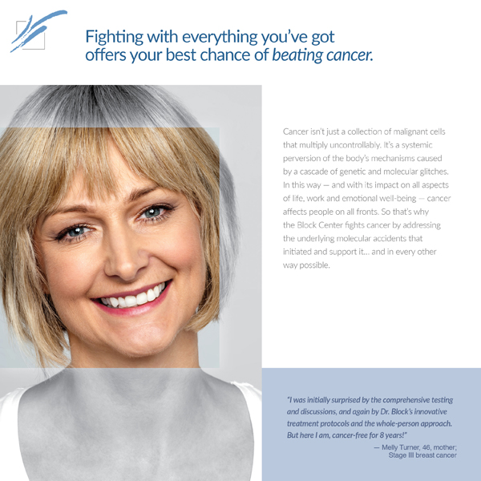

**Mandatories**

Patient testimonials (with photos), ideally with full-name attribution

Simple, undeniable truths

Professional testimonials

*- end -*

*Best of conventional medicine*