ONLINE Intake Form
PRACTICE SPECIFICS
Practice Name: | Carolina Vein Specialists
Physician’s Name: | Brent Greenberg, MD, FAAFP, RPhS Mark Featherston, MD
Practice Address: | 1130 New Garden Rd. Greensboro, NC 27410  1598 Westbrook Plaza Dr. Winston-Salem, NC 27103
Phone Number: | 336-218-8346 | Fax Number: | 336-218-0145

Do you have testimonials for the website? If yes, please send them to us. Yes: they are on our current website in video format. They are all stored on our YouTube channel

Design Questionnaire
The Design Questionnaire will help our website designer create your website and tailor it to your likings. We will not be building a new website for now, we just want you to adjust the existing website based on your group’s recommendations. We need to add our IAC accreditation logos to the main page will be sent to Airaby.

Describe at least three (3) web sites that your organization likes and why:
Web Address |  | What do you like about it/Why | What do you dislike about it/Why
1 | Carolinavein.com | It’s paid for and finished! | Black hat problems that need to be fixed.
2 | [Click here to type] | [Click here to type] | [Click here to type]
3 | [Click here to type] | [Click here to type] | [Click here to type]
4 | [Click here to type] | [Click here to type] | [Click here to type]
5 | [Click here to type] | [Click here to type] | [Click here to type]

What style would you like to achieve? Please see the example below & check the appropriate boxes:

☐Bold ☐Innovative/Compassionate
☐Clean ☐Medical
☐Conservative ☐Modern
☐Corporate ☐Other _________________________
☐Elegant

Bold | Clean
 | 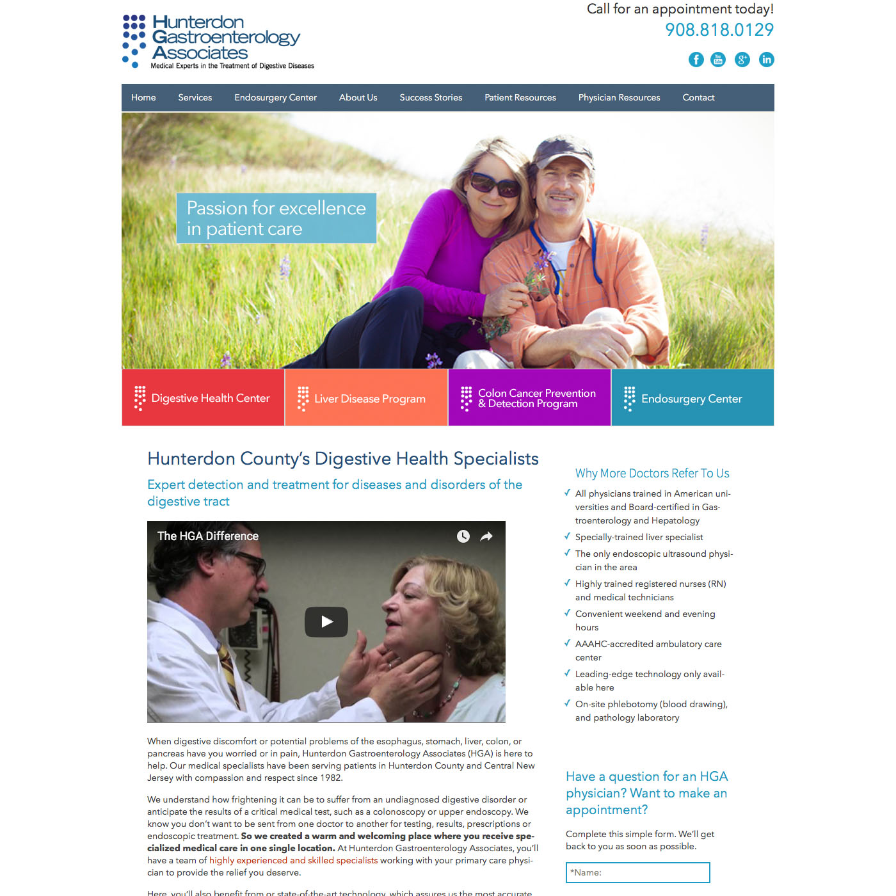

Conservative | Corporate
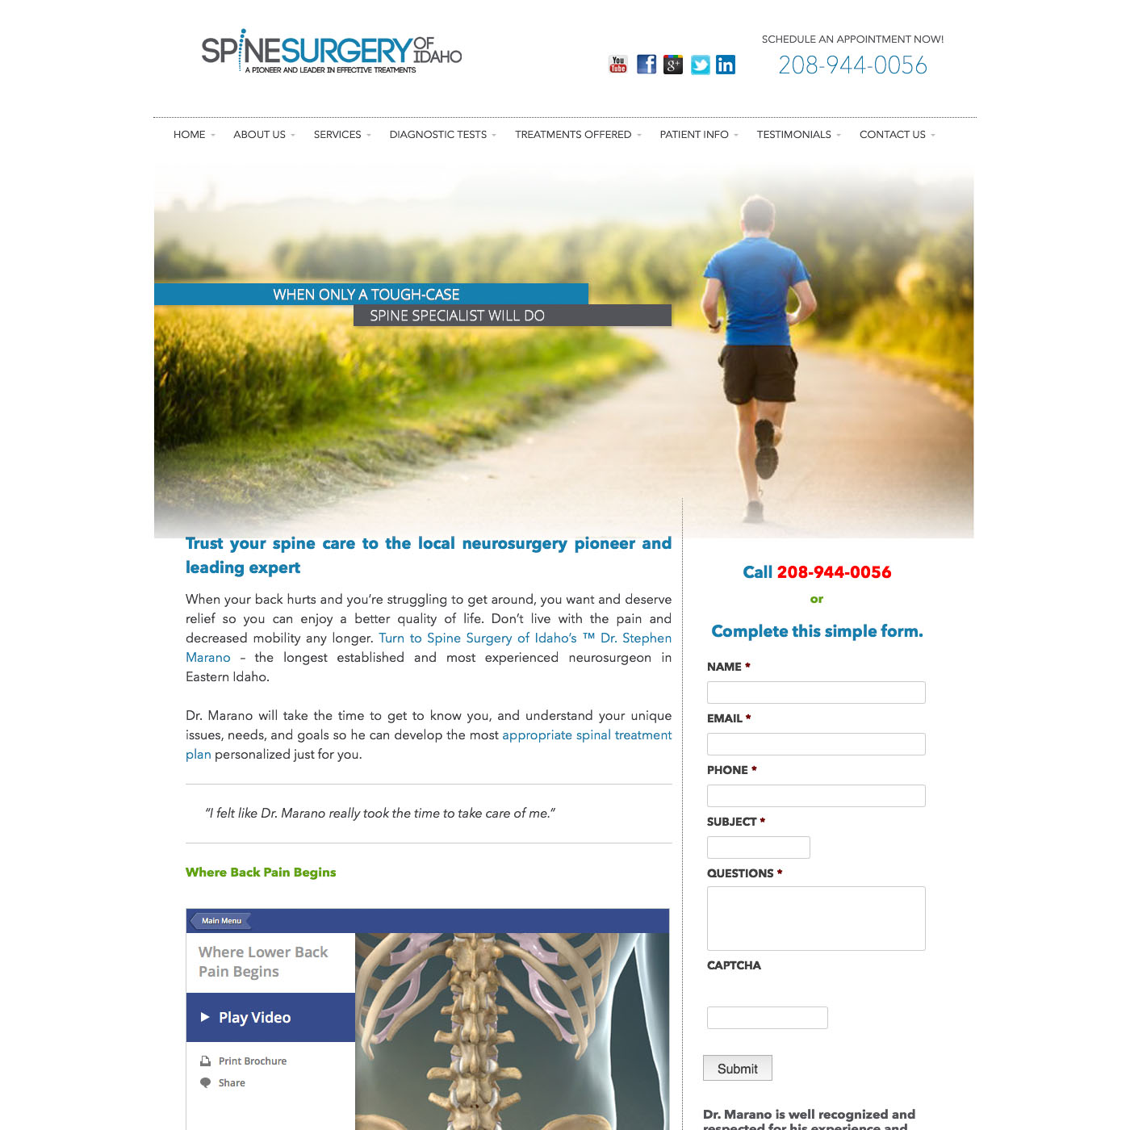 | 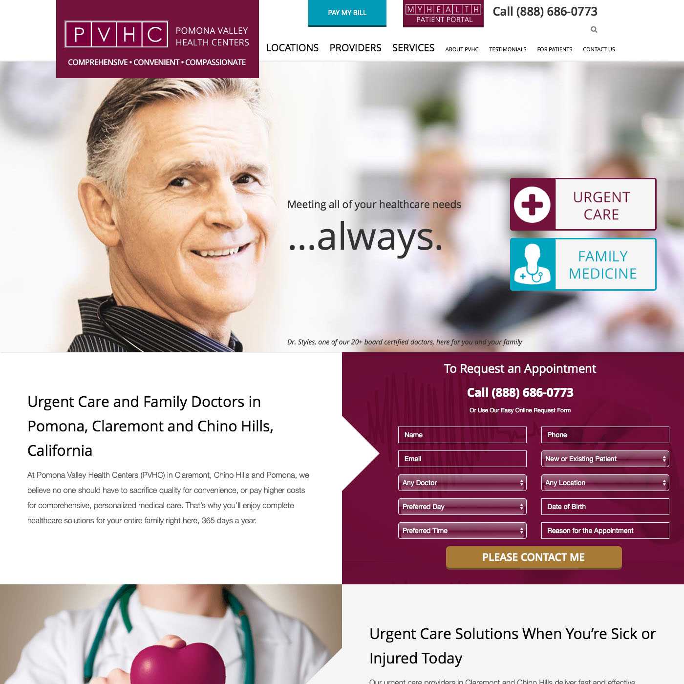

Elegant | Innovative/Compassionate
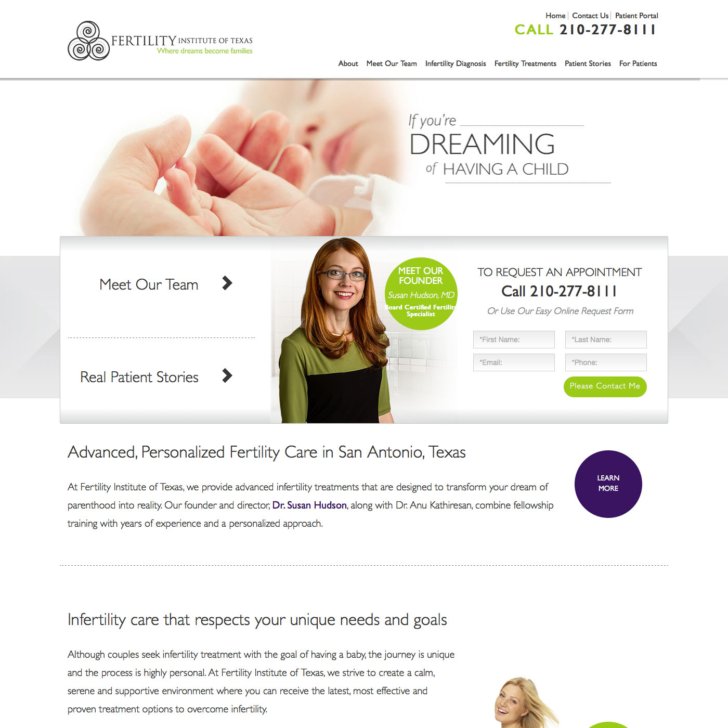 | 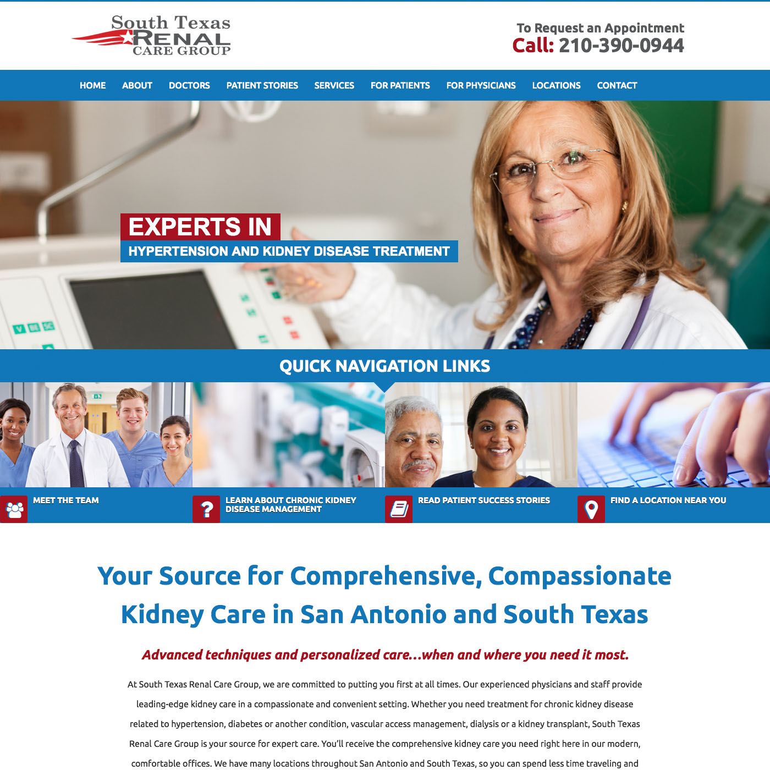

Medical | Modern
 | 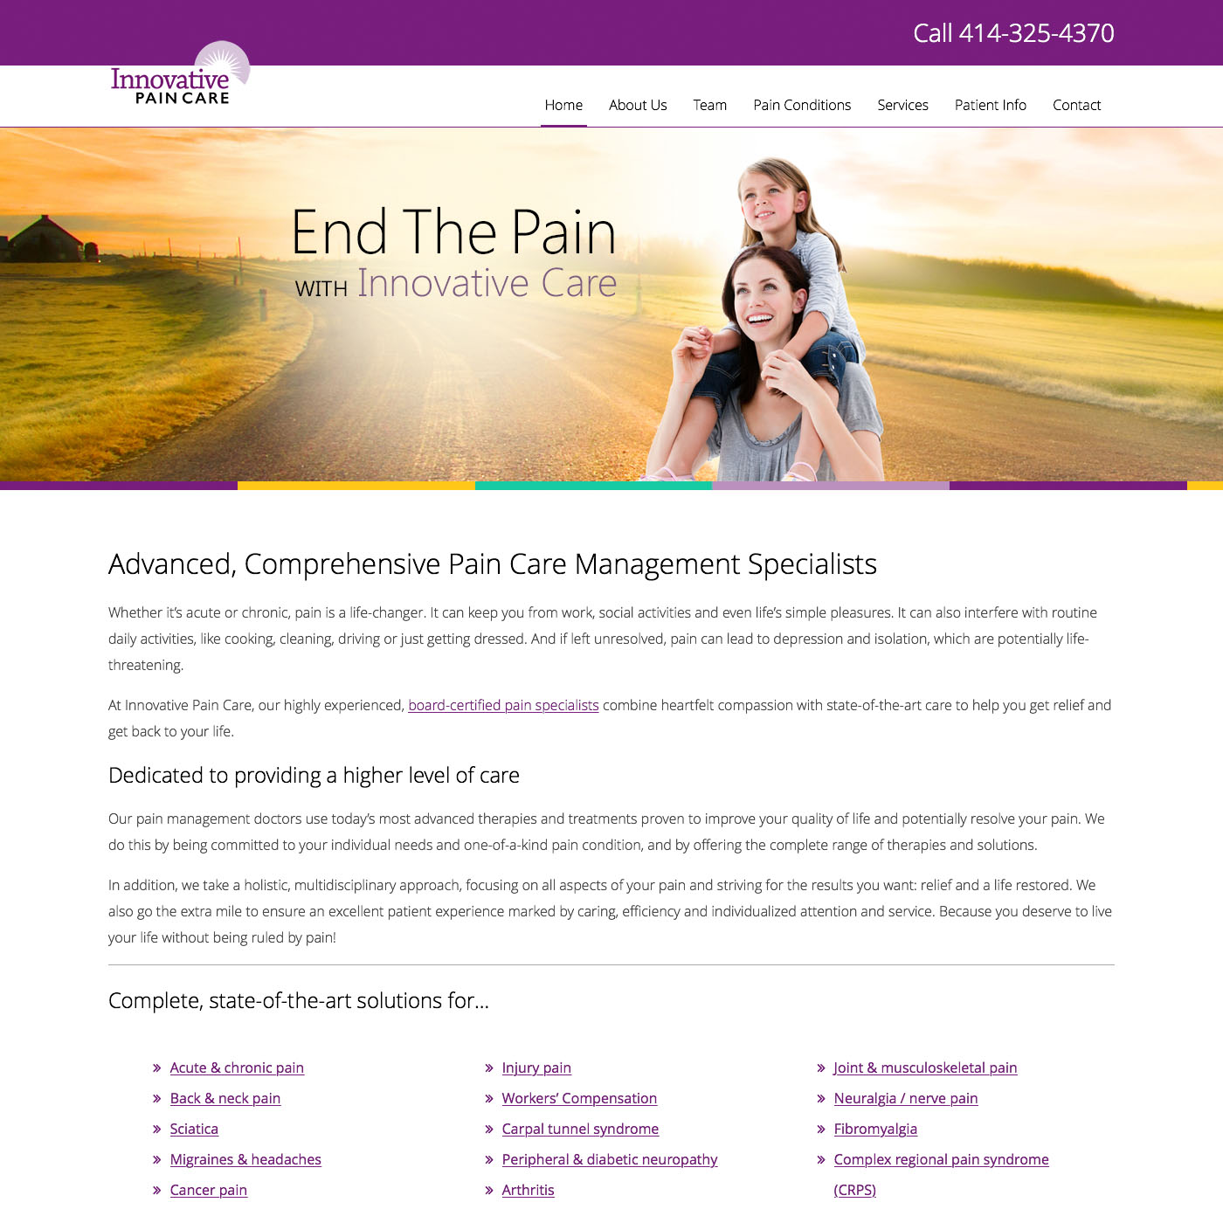

Do you currently have the art files for your logo? If yes, please send it to us in EPS, AI or PDF format.

Coding/Development Questionnaire
Do you have an existing URL you’d like to use? [Click here to type existing URL address.]
Who in your organization will be responsible to receive incoming leads? [Click here to type]

Login Information:
Website Login [WordPress, Joomla (CMS Platform)]
The website login credentials will give us access to your current website and allow us to review the current set up of the site structure.

[URL]: [Click here to type]
[Username]: [Click here to type]
[Password]: [Click here to type]

Domain Registrar (GoDaddy, Network Solutions, etc.)
The domain registrar credentials will let us direct the domain to the new hosting location.

[URL]: [Click here to type]
[Username]: [Click here to type]
[Password]: [Click here to type]

Hosting Information
The hosting login credentials will let us easily transition the site.

[URL]: [Click here to type]
[Username]: [Click here to type]
[Password]: [Click here to type]

FTP
The FTP login credentials will let us access the files on your existing site.

[Server Address]: [Click here to type]
[Username]: [Click here to type]
[Password]: [Click here to type]

Blog Login (If applicable)
The blog login credentials will give us access to your blog if your blog does not have the same login or password credentials as your normal website.

[URL]: [Click here to type]
[Username]: [Click here to type]
[Password]: [Click here to type]

SEO Questionnaire
SEO & Writing Questionnaire
The information requested below will help us perform link building and SEO on future campaigns.

Who are your top 3 competitors? Vascular and Veins Specialists of Greensboro, Salem Vein and Vascular, Vein Clinic of North Carolina (Dr. Scott Baker)

Do you refer any patients to other doctors/practices? If so, who? Dr. Moore and Vascular and Veins Specialists for deep vein problems

Do any doctors/practices refer patients to you? If so, who? Several primary care, ob/gyn, podiatry, and dermatologists

What are your top 5 focuses/specialties you’d like us to target with SEO, whether it’s in areas you’d like to grow or the specialties with the highest ROI?
- Primary care
- Ob/Gyn
- Plastics
- Podiatry
- Dermatology

Geographical Questions

How far do most of your current patients drive to get to your practice? (Please indicate just one.)
10 Miles or Less 10-30 Miles 31-100 Miles 100+ Miles
Uncertain
Health Directories Questionnaire
The personal information requested below is required for security reasons by Vitals, HealthGrades and RateMDs. Without this information, we will not be able to update and manage your profiles.

Should you decide you’d like to complete this process yourself, gather the information as directed here and set up your account on each of the corresponding websites. Please let your account manager know once setup has been completed and provide login details to us, so we can monitor and update your account as needed.

Google My Business Login (if applicable)
[Username]: [Click here to type]
[Password]: [Click here to type]

I don’t think we have a google my business account?

VITALS (LIST FOR EACH PHYSICIAN IN PRACTICE)

Physician Legal Name | Brent Greenberg | Mark Featherston
Physician Date of Birth | 01/31/67 | 04/16/63
Physician State License Number | 2008-01798 | 39366
Physician State License State

Physician NPI Number | 1851369600 | 1073572533

RATEMDS (LIST FOR EACH PHYSICIAN IN PRACTICE)
Copy of Physician's Driver's License: Why?
Healthgrades (LIST FOR EACH PHYSICIAN IN PRACTICE)

Physician Name | Brent Greenberg | Mark Featherston
Last 4 digits of physician DEA number | 5835 | 4648
Last 4 digits of physicians Social Security number | 6378 | 4970

SOCIAL MEDIA Questionnaire

Who in the practice will be responsible for posting social media content?
Name [Click here to type] We anticipate you will do the posting, but you can ask Dr. Greenberg or Stefanie Allen about what our providers and staff are doing to add personal content
E-Mail [Click here to type]

The information requested below will help us access your social media profiles to begin your Social Media Optimization. Log in information will only be used on an as needed basis, as mutually agreed.

Facebook Login (if applicable) When I first set up our FB account, I made a mistake and made our business account in a personal account. Our business account now sits in the personal account. It’s a mess. I can explain more later.
[Username]: cvsvein@gmail.com
[Password]: bgmf1130

Twitter Login (if applicable)
[Username]: [Click here to type] No twitter account
[Password]: [Click here to type]

Yelp Login (if applicable) No Yelp account
[Username]: [Click here to type]
[Password]: [Click here to type]

Google+ Login (if applicable) carolina-vein-l-5990@pages.plusgoogle.com
[Username]: cvsvein@gmail.com
[Password]: veinsuccess2020 (updated by HS 1/22/20)

Pinterest Login (if applicable)
[Username]: [Click here to type]
[Password]: [Click here to type]

LinkedIn Login (if applicable) No Linked In account
[Username]: [Click here to type]
[Password]: [Click here to type]

YouTube Login (if applicable) https://www.youtube.com/channel/UClRkNoJ2oMJQXRfoQ5fxR4g
[Username]: cvsvein@gmail.com
[Password]: 652645

What additional social media pages do you require? Check all that apply.
☐ Facebook ☐ YouTube
x Twitter
x LinkedIn
☐ Google+
Which holidays would you like promoted on your social networks?
☐ New Year’s Day Don’t care
☐ Martin Luther King, Jr. Day
☐ Valentine’s Day
☐ Presidents’ Day
☐ St. Patrick’s Day
☐ Passover
☐ Easter
☐ Mother’s Day
☐ Memorial Day
☐ Father’s Day
☐ Independence Day
☐ Labor Day
☐ Columbus Day
☐ Halloween
☐ Veterans Day
☐ Thanksgiving Day
☐ Christmas Day (Merry Christmas)
☐ Happy Holidays instead of Merry Christmas
☐ Other
For “other”, please list the holidays you would like observed and the dates they fall on:
___________Whatever you guys think._____________________
________________________________
________________________________
________________________________
________________________________
________________________________
________________________________

