**Digital Campaign Creative Brief**

Client: CAROLINA VEIN SPECIALISTS

DATE: 5/6

PROJECT NAME: CVS POST COVID CREATIVE & FREE VEIN SCREENING

CREATED BY: Kat

New campaign []

Refresh on existing campaign X]

Addition to existing campaign [ ]

**OBJECTIVE:** Ramp up new patient conversions post-COVID.

**BACKGROUND:** Carolina Vein Specialists is being allowed to return to their offices and procedures starting May 11.

They have long run a TV campaign with us on up to 4 stations at a time, every month, 12 months a year. They run both :30 sec and :15 sec spots.

They have also maintained a monthly paid search and Facebook advertising campaign with us every month.

Facebook advertising dollars (in the budget of $750/mo) are conserved throughout the year and then spent in “buckets” to support free vein screenings.

Free Vein Screenings happen sporadically throughout the year, typically 6-9 weeks apart.

A typical schedule looks like this:

* Feb – Valentine’s Day FREE Screening
* Late March – Spring FREE Screening
* May – Mother’s Day FREE Screening
* July – Freedom Day FREE Screening
* September – Back to School FREE Screening

We also send 4 Postcards per year – One supports the Feb. vein screening, one supports the Mother’s Day screening, and the other two target Medicare in Q4.

**BUDGET:** Their monthly budget is variable for FB and TV. See [official budget here](https://docs.google.com/spreadsheets/d/15A-icZ-GrNM4vQ4JUq98ttbOJFA-3xsYO1Q9tfiFg10/edit?usp=sharing).

We cut short our FB advertising in March, did not run in April, and are now already into May. We should have at least $1500 - $2000 to run 1 screening ad on for 2 weeks.

We did NOT do a May mailer, so we also have $3,750 conserved from that bucket, and another $11K left over from TV media we did not run in April. If we need this budget for a FB partnership, we can likely tap it.

**TARGET AUDIENCES & DEMOGRAPHICS:**

Locations:

* Greensboro (within 25 mile radius of clinic)
* Winston-Salem (within 25 mile radius of clinic)

Age: 30+

Gender: Female

Status: N/A

HHI: $50K (US)

Insurance: All (excluding BC/BS), including Medicare

**SECONDARY TAREGT AUDIENCE:**

Locations:

* Greensboro (within 25 mile radius of clinic)
* Winston-Salem (within 25 mile radius of clinic)

Age: 40+

Gender: MALE

Status: N/A

HHI: $50K (US)

Insurance: All (excluding BC/BS), including Medicare

**WHAT DO WE WANT AUDIENCE(S) TO DO?** Pick up the phone or visit the website for an appointment.

**LOCATION TARGETING:** [FILL IN]

**DURATION OF CAMPAIGN:** Our TV schedule is slated to get back to normal starting May 25th. Facebook campaigns run only 2 weeks at a time every 6-9 weeks and only in support of free vein screening events.* (*typically)

**DELIVERABLES:**

* Revised TV script (:30 sec)
* Revised Free Vein Screening for June 15th (?)

**VISION FOR CREATIVE:**

**This is a refresh of existing campaigns:**

**:30 sec TV spot:**

https://www.dropbox.com/s/uzr2x685by2z12x/XLV_CAROLINAVEIN-TREATVEINS-B-R3.mp4?dl=0

**:15 sec TV spot (free vein screening promo):**

https://www.dropbox.com/s/qau10ju1mbn5j7z/XLV_CVS-MAR_SCREEN2020.mp4?dl=0

**FB Ad:**

<https://www.dropbox.com/sh/k8pmgzuir6ryd1k/AACh-FtVFMZivVZ2vRGH2tsPa?dl=0>

**FB Ads MAY utilize :15 sec TV spots, but may NOT use the same tracking number contained in those spots.**

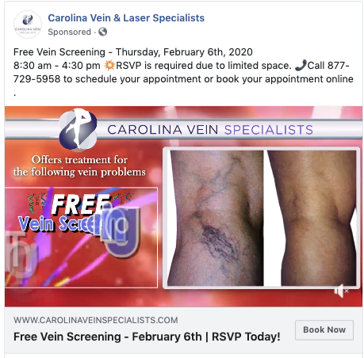

Images should reflect the target audience (as typically seen after the procedure – happy, healthy, returning to normal activity), select imagery projecting symptomatic issues is ok in limited fashion.



**MESSAGING/COPY FOR AD CREATIVE:**

* **COVID SPECIFIC:**
* We’re back in the office and we’re looking forward to seeing you!
* You’ve waited long enough to feel the freedom from heavy, aching, painful legs, DON’T WAIT ANOTHER SECOND – CALL FOR AN APPOINTMENT!
* Drs. Featherston and Greenberg have performed thousands of successful procedures in the North Carolina
* Combined 20 + years experience
* Condition Symptoms
  + Varicose veins
  + Spider veins
  + Leg pain and swelling
  + Restless legs
  + Blood clots/DVT
  + Phlebitis
* COMMON RISK FACTORS FOR VEIN DISEASE:
  + Age and gender
  + Prolonged sitting or standing
  + Pregnancy and hormonal changes
  + Being overweight
  + Leg injury or trauma
  + Sedentary lifestyle
* Vein Treatments
  + VenaSeal™ Vein Closure
    - FIRST and only vein practice in the triad (possibly the whole state) using this treatment.
  + M.O.C.A – ClariVein
  + Endovenous Laser Thermal Ablation (EVLT/EVLA)
  + Endovenous Chemical Ablation
  + Sclerotherapy
  + Ambulatory Phlebectomy/Microphlebectomy
  + Compression Hose/Support Stockings
* **Benefits of treatment:**
  + **Erase embarrassing varicose, painful varicose veins in a single day!**
  + Return to activities you enjoy
  + Little to no down time with these advanced technologies
  + Return to work/pleasurable activities same day
  + Most insurances

*Feel free to use patient testimonials from anywhere!*

**DESTINATION URL**

www.carolinaveinspecialists.com

**LIVE DATE:** Monday,May 26th (for TV and FB Free Vein Screening Ads)

**Proposal for FB Live Event should be fully hashed out by June 8**