Log in…and you should see this:

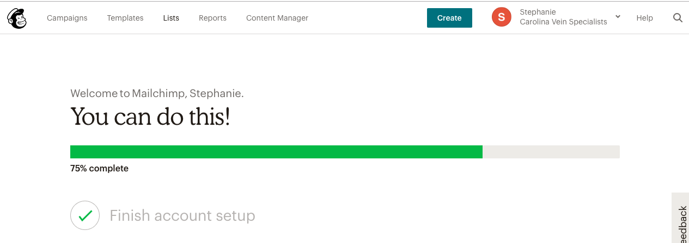

Click “Lists” at the top of the navigation, and you should end up here:

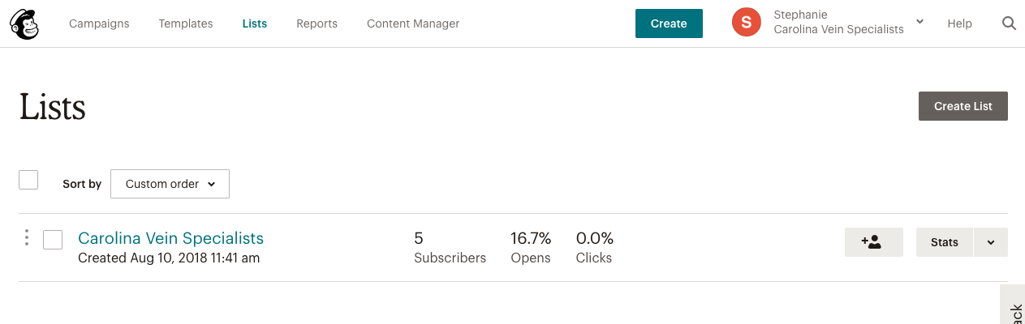

After you click on “Carolina Vein Specialists” you should see a preview of everyone in your list:

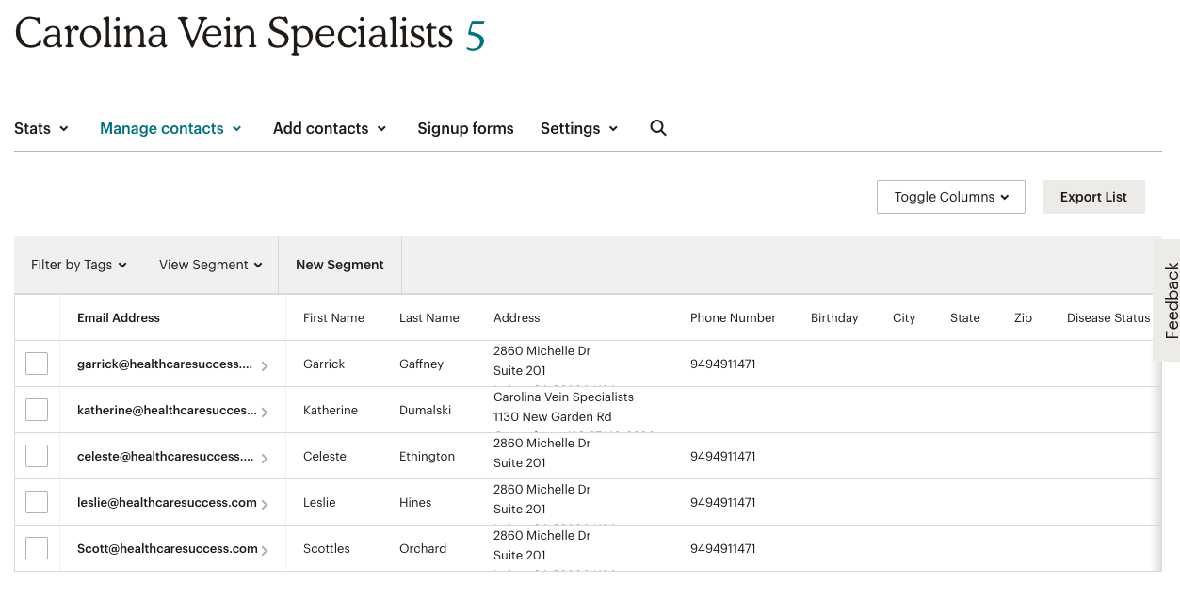

Click “Add Contacts” and from the drop down menu select “Import Contacts”:

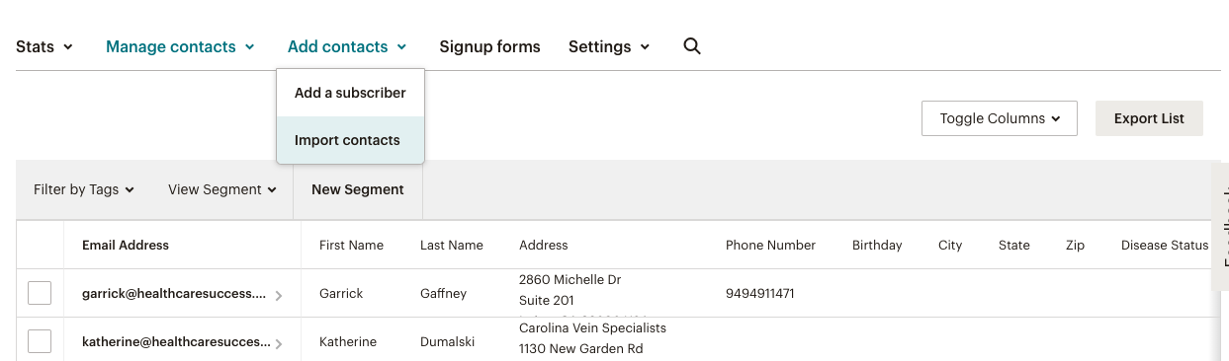

You will be able to upload a csv or xls file. BEFORE DOING THAT, make sure you’re only uploading one segmented list at a time so that you can easily apply the appropriate tag to ALL contacts you plan to import.

You can choose to upload your list using the default columns from my last import, or start over and manually match columns (you’ll probably have to do this either way.

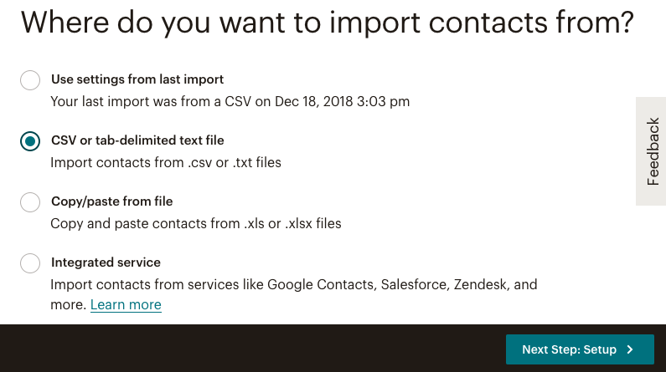

After you’ve selected a file to upload, click “Next Step Set-Up”. (*Duplicate addresses will be removed. We do not send confirmation emails to imported addresses.*)

Match columns, and click “Next”:

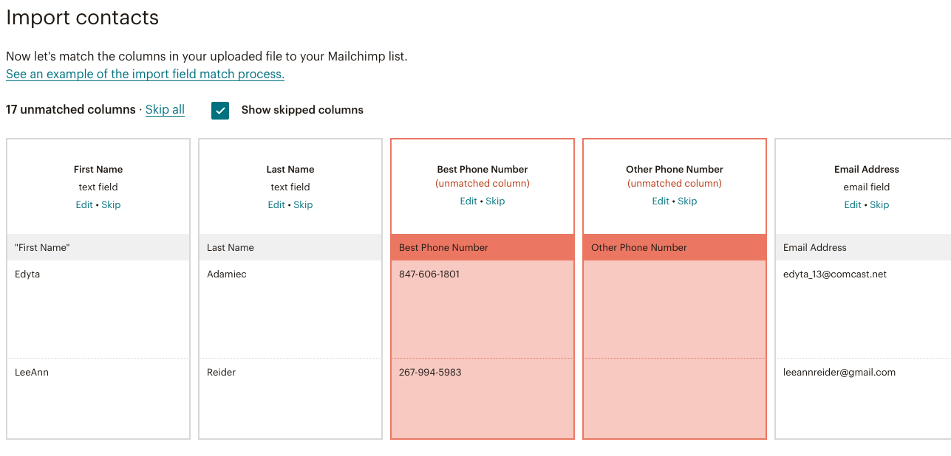

Select the proper tag (are they No-Shows to their initial appointment? recently converted to a consult but then didn’t book their EVLT treatment?, etc)

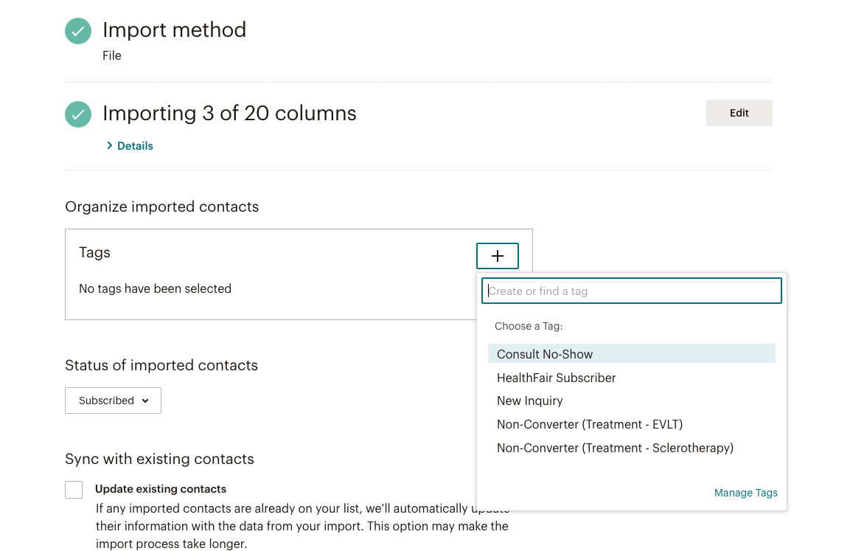

Click “Import” and you’re done! The system will take care of the rest.