Basic Company Information
Business Name | Cutting Edge Integrative Pain Centers
Business Owner | Orlando Landrum
Country | USA
Address | 244 Waterfall Dr.
City | Elkhart
State | Indiana
Zip Code | 46516
Phone Number | 574-821-4363
Fax Number | 574-855-5288
Website | http://michianapainrelief.com
Business Contact Email | cuttingedgepain@gmail.com
Year Founded | 2017
# of Employees | 6
Business Description (up to 200 characters) | We’ve built our practice around our dedication to long-lasting pain management — not temporary remedies. By listening to your symptoms and looking at the core of what’s causing your pain, our pain specialists will craft a comprehensive plan to relieve your pain.
Business Description (up to 500 characters) | As an interventional pain care group, we’re highly trained at fixing the source of your pain with minimally invasive procedures. And as an integrative practice, we also prescribe the full range of pain treatments, including:  - Endoscopic surgery  - Advanced regenerative medicine techniques  - Traditional pain relieving injections  - Combined electrochemical therapy  - Physical therapy  - Neurofeedback  Medications
Payment Types Accepted | Insurance, credit cards, cash
Hours: Open-Close | Monday-Friday: 9am-5pm
Appointment Only (Y/N) | Y
Languages Spoken | English
Primary Categories | Upper and lower back pain, complex regional pain syndrome, peripheral neuropathy, migraines, cervical spinal stenosis, occipital neuralgia, lumbar radiculopathy (sciatica), cluster headaches, piriformis syndrome
Specialties | Endoscopic spine surgery, spinal cord stimulation, advanced regenerative medicine techniques, facet rhizotomy, neurofeedback and transcranial stimulation, transforaminal epidural steroid injection, ultrasound-guided joint injections, combined electrochemical therapy, coolief cooled radiofrequency ablation, kyphoplasty
Company Slogan/Tagline | N/A
Company Logo | 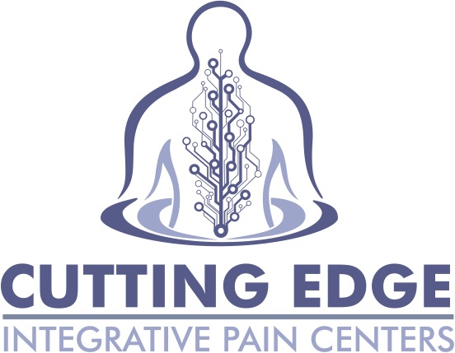
Social Media Accounts
Youtube Video URL 1 | https://www.youtube.com/channel/UCytGqaJEM3cg1lwtfWAKtZg
Youtube Video URL 2 | https://www.youtube.com/channel/UCmSV-EfbXdo4Rq7cWh7tARw
Facebook Profile Link | https://business.facebook.com/Cutting-Edge-Integrative-Pain-Centers-229798794182470/?business_id=10152895006206652
Twitter Profile Link | https://twitter.com/MichianaPain
LinkedIn Profile Link | Not available yet
Google Local Profile | Not available yet
Images
In red because we are in the works of creating a landing page—aka no info

