Questions for GCHC

3/6/19

Since unearthing this new info, I’ve gleaned a ton of relevant facts for Boyington Health and Rehab in Gulfport MS. Question is, **do other facilities offer such an extensive list of SERVICES?**

Here is a section of the flyer Greg found with all their services (90% of which aren’t listed in the facility by location info doc or their existing site):

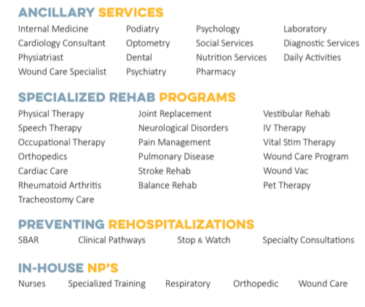

It would be helpful to know if other centers have this expansive of a service menu as I go back to update the existing microsites…

Also at Boyington, **how does the Hospitalist program with Memorial Hospital work?** Does a doctor who works out of Memorial treat patients onsite at Boyington? (there is a broad definition of “Hospitalist” but I’m wondering how they define it at Boyington)

They have 14 private therapy suites – are these for **Restorative Nursing care in particular?**

One last thing: **Is it “Boyington?” Or “The Boyington”** (their flyer and other materials and the current microsite clash on name use)