**Research** – Yahoo! Ads

**About Yahoo ads:**

**TYPES OF ADS:**

**Native:**

**Search:**

**To maximize clicks:**

* Write the best possible ad
* Tap in to latest news, trends and seasons
* Ask yourself, “Would I click this?”
* Test it
* Always have at least 5 ads

**TEXT:**

* Clear, factual, specific, relevant to your keywords
* Good grammar
* Avoid superlatives
* Avoid excessive capitalization
* Avoid exclamation points
* Be sure your ads and keywords comply with Native & Search policies
* Make sure the audience feels your message (feel, not think)
* Talk to the audience, not over their heads. They aren’t experts.
* Make believable claims. Be truthful, honest. Earn their trust.
* Call to action: make an offer, motivate the undecided, offer extra info that compels users to take the next step.
* Be relevant
* Keep message on-brand
* Be bold; use strong, enticing language, but don’t drive users away feeling they have to commit too early on
* Be short and to the point
* Be persuasive
* Use Igniters, Enlighteners, send to a site

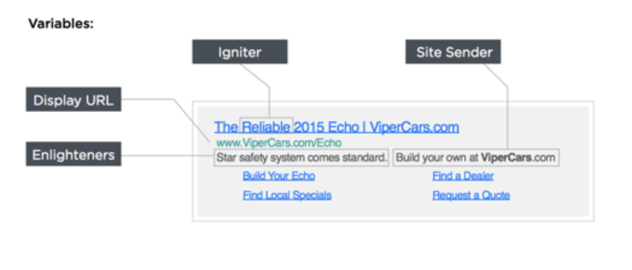

**LOOK UP:**

* What is “content native”
* Native & Search policies

**TITLES:**

* Benefits, not features: Solve a problem, empower the user
* Keep targeting segments in mind
* Use title case
* Directly relate the product/service to the user
* Make full use of the 50 characters

**DESCRIPTIONS:**

* Should be a natural read
* Avoid extraneous punctuation
* Use sentence case
* Use Sponsored By field to tell users who you are
* Make full use of the 150 characters

**GRAPHICS:**

* Try not to use logos
* Faces perform well
* 1200 x 627

|  |  |
| --- | --- |
| **MAIN IMAGE**  (Required) | * 1200x627 image * Wide aspect ratio main image. * Asset Name: secHqImage |
| **ICON IMAGE**  (Required) | * 82x82 max, may be slightly smaller * For app advertisers, this is the app icon * Asset Name: secImage |
| **AD TITLE**  (Required) | * 50 maximum character length string of ad headline * Provide enough space to display the entire length of the Ad Title * Asset Name: headline |
| **AD COPY**  (Required) | * 150 maximum character length string of ad text * Provide enough space to display the entire length of the Ad Text * Asset Name: summary |
| **ADVERTISER NAME** (Required) | * 30 characters maximum * Provide enough space to display the entire length of the Advertiser Name * Asset Name:**source** |
| **CTA TEXT**  (Required) Only provided for the Install Ads (?) | * Text for a button * 12 characters maximum * Use "Install" with app advertisers and "Learn more" with non-app advertisers * Provide enough space to display the entire length of the CTA Text * Asset Name: callToAction Note: this asset is provided only for the Install ads. |
| **SPONSORED MARKER** (Required) | * Text for a button * 12 characters maximum * Use "Install" with app advertisers and "Learn more" with non-app advertisers * Provide enough space to display the entire length of the CTA Text * Asset Name: callToActionNote: this asset is provided only for the Install ads. |
| **APP RATING**  (Not Applicable) |  |
| **APP CATEGORY** (Not Applicable) |  |

**Source:** <https://developer.yahoo.com/flurry/docs/publisher/gettingstarted/nativeadguidelines/>