**Creative Brief**

HURON REGIONAL MEDICAL CENTER

DATE: 4/22/20

PROJECT NAME: **Q2 Social Media AD CAMPAIGN**

CREATED BY: BRYCE ARROYO



Existing Campaign Refresh [ X ]

**BACKGROUND:**

* HRMC digital ad creative has not been updated for some time. Before reactivating the campaigns currently on pause, the client has requested HS develop new ad creative to re-launch new social media campaigns for Women’s Wellness Center and Physicians Clinic.

**MARKETING CAMPAIGN OBJECTIVES:**

* Refresh Creative for each Campaign that speaks to the audiences’ needs and concerns (including during these COVID times), and continues generating new patients.
* Incorporate and push Telemedicine awareness to Physicians Care websites to generate new patients.

**CAMPAIGN PERFORMANCE METRICS:**

* HRMC digital advertising ads were not active Jan - Mar 2020. So, campaign goals will be to exceed Q419 performance. See chart below.

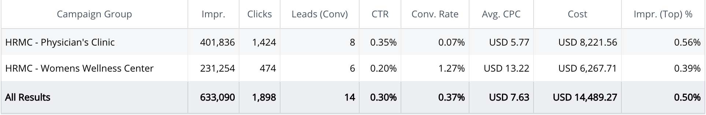

**THE ASSIGNMENT/DELIVERABLE:**

* Update Keywords and Retargeting (Usage of patient emails) in both Google Search & FB Ads.
* Refresh creative (copy, imagery, video assets) for the two campaigns:
  + Women’s Wellness (2 messaging/creative versions)
    - OBGYN Issues
    - Staying safe during COVID…. Use in messaging for Copy.
  + Physicians Clinic
    - Telemedicine focus, with the ability for the creative to be easily updated if/once telemedicine is not the main message
    - (Per Dana) For use with other clients, (3) telemedicine creative options should be developed that could be repurposed and customized for a variety of clients in different geographic locations who all have similar needs and messages.
    - The link below will connect to a library of selects - illustrations that depict telemedicine that could be used to create videos that tout telemedicine. We can deconstruct and reconstruct these illustrations with supers (greg) and music to tell a story.
      * Maybe two very different illustrations styles, and one that is simply icons or icons on top of photography.
      * <https://shared-assets.adobe.com/link/55df7f0f-6dda-496f-574d-1d6801318b56>

**BUDGET & DURATION OF CAMPAIGN:**

* Digital Media: May : $2,700 **net**/mo
* Digital Media Cont. : June - December: $900 **net**/mo

**CHANNELS/MEDIUMS PROJECT WILL LIVE IN:**

* Facebook & Search - CTAs will drive to respective websites

**DESTINATION URL:**

* Physicians Clinic: <https://www.hrmcphysiciansclinic.org/>
* Women’s Wellness: <https://huronobgyn.org/>

**LOCATION TARGETING:**

* HRMC only has one location. Huron, SD
  + Should target a 10mi radius, as well as these neighboring cities
    - Watertown, Aberdeen, Brookings, Mitchell, Chamberlain

**TARGET AUDIENCES & DEMOGRAPHICS:**

* Physicians Clinic - provides you and your family the right care for: Family Medicine, General Surgery, Orthopedics, Pediatrics, and Urology.
* Women's Wellness Center - focus is on females that fall within one of the following categories:
  + OB/GYN issues
    - Heavy bleeding
    - Endometriosis
    - Immediate medical needs
  + Pregnant and seeking information about how to stay safe during COVID

**WHAT DO WE WANT AUDIENCE(S) TO DO?**

* Physicians Clinic: Call and book an appointment (telemedicine)
* Women’s Wellness Center
  + OBGYN issues: Call and make an appt if experiencing issues
  + Pregnant women: Reference HRMC’s helpful information on how to stay safe during COVID

**MANDATORIES:**

* Follow Gabi’s guidelines for developing the video assets:
  + **Creative:** 2 videos from Animoto in two aspect ratios (total of 6 videos = 2 for PC campaign, 4 for WW campaign). Captions and Sounds are recommended. Text must be less than 20% of the creative
  + **Duration**: 5-15 Seconds
  + **Aspect Ratios**: 1:1 , 9:16 , 16: 9 (4GB Max file size)

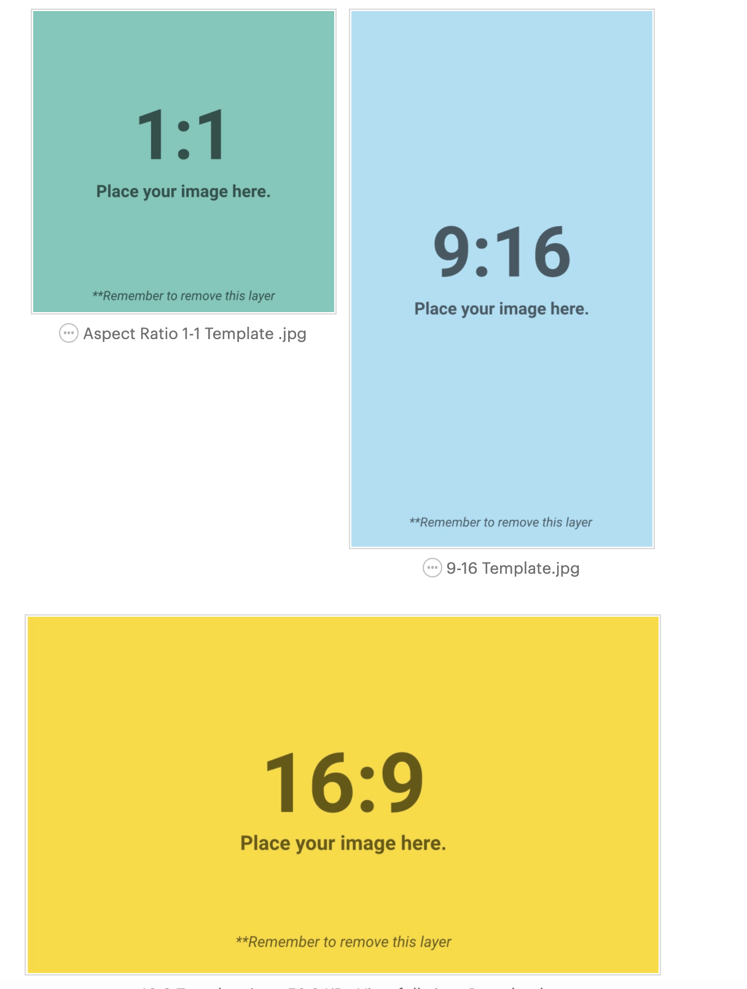

* + **Copy:** 2 of the Same Messaging per campaign

Description: 125 characters

Headline: 25 Characters

Text Description: 30 Characters

Add recos:

Keep your text short, clear and concise to get your message across. Make it emotional and how it will benefit the consumer with a clear CTA.

Choose a testimonial from the website or a review. Personal stories are also great.

Do not ask questions in your copy

**TIMING:**

* Ads should be launched on Mon, May 4th

COPY: (WWC)

* At Women’s Wellness Center in Huron, we are women who care for women. We believe in wellness for the “whole patient,”.
* No matter the situation, Women’s Wellness Center in Huron is driven to understand and create comprehensive plans for all your needs.
* Deciding to start a family can be one of life’s most exhilarating experiences. Yet, getting pregnant can have its challenges. At Women’s Wellness Center, we help you overcome them with infertility testing, counseling and treatment.
* We are passionate about providing the most appropriate, most effective alternatives to treat many conditions, at Women’s Wellness Center “ We Care”.

COPY: PC

* During times like these, ensure your family is taken care of. HRMC is now offering telemedicine appointments, check the website to set your appointment TODAY!
* HRMC is here for all your needs, big & small don’t be alarmed. Contact us today, so we can ensure you get the best care.
* Don’t let Covid-19 scare you away, here at HRMC we have ensured our patients will receive the best line of care. Ranging from in-person appointments, and Telemedicine appointments from the comfort of your home